**HOMEWORK 8**

**JASPREET KAUR**

**001529746**

1. Consider the following string: “ABDCCEDDFCABBCCEFDDAAFF”

a) What is R value?

b) Use key-indexed counting sort algorithm to sort the string. Show each steps

and the results.

c) What is the running time complexity of the algorithm as compared to Heap sort?

d) Write the java code to sort the string using steps described in (a)

Answer – a) The maximum element(range) of array is called R value.

b) Frequency of every element –

|  |  |
| --- | --- |
| A | 4 |
| B | 3 |
| C | 5 |
| D | 5 |
| E | 2 |
| F | 4 |

Cumulative Sum –

|  |  |
| --- | --- |
| A | 4 |
| B | 7 |
| C | 12 |
| D | 17 |
| E | 19 |
| F | 23 |

Left indexing the loop by 1-

|  |  |
| --- | --- |
| A | 3 |
| B | 6 |
| C | 11 |
| D | 16 |
| E | 18 |
| F | 22 |

Separating –

|  |  |
| --- | --- |
| A | 0-3 |
| B | 4-6 |
| C | 7-11 |
| D | 12-16 |
| E | 17-18 |
| F | 19-22 |

The final string – “AAAABBBCCCCCDDDDDEEFFFF”

c) Time complexity -> O(n+r)

n -> number of elements

R -> maximum element(range) of array

On the other hand, time complexity for heap sort is O(nlogn).

d) JavaFiles/Qs1.java

2. The following Ford-Fulkerson network Flow graph problem shows 2nd iteration of the original graph. Show the remaining iterations step-by-step algorithm including data structures

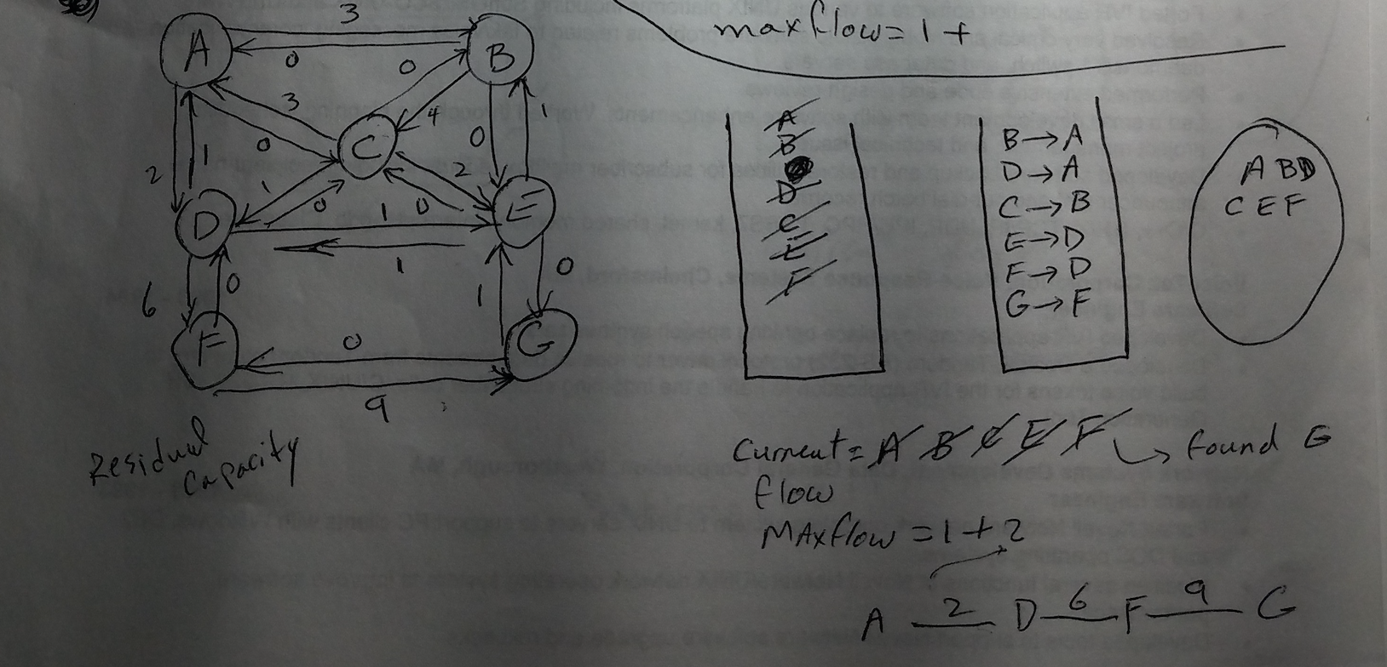

and augmented-paths to find Maximum Flow from source A to destination G.

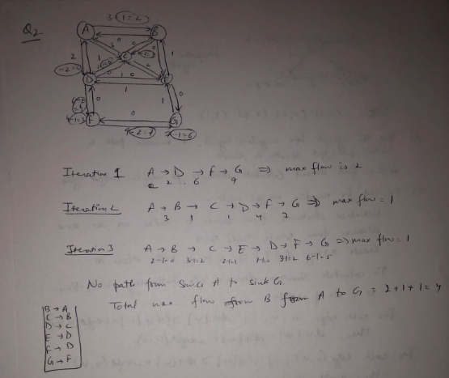

3. Consider the following graph. A) Find the shortest path from source vertex A to any destination vertex on the graph. Show the data structures and step-by-step algorithm to find solutions presented in data structures. B) Explain how to use Path-map data structure to find path from A to any other destination.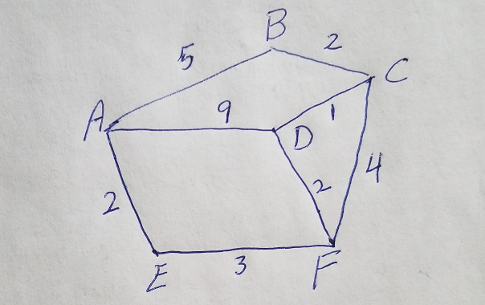

Dijkstra’s algorithm –

1. Sort G in L  
2. Set distance to the source to 0;  
3. set the distance to all other vertices to infinity;

4. For each vertex u in L

i) Walk though all neighbors v of u;

ii) If dist(v) > dist(u) + w(u,v)

dist(v) = dist(u) + w(u,v)

So as per the algorithm first set initial vertex which is A to itself distance as 0. Set start vertex to every other vertex distance to infinity. And then check for all given vertex as per the given loop and check for the condition which is,

If dist(v) > dist(u) + w(u,v), then dist(v) = dist(u) + w(u,v).

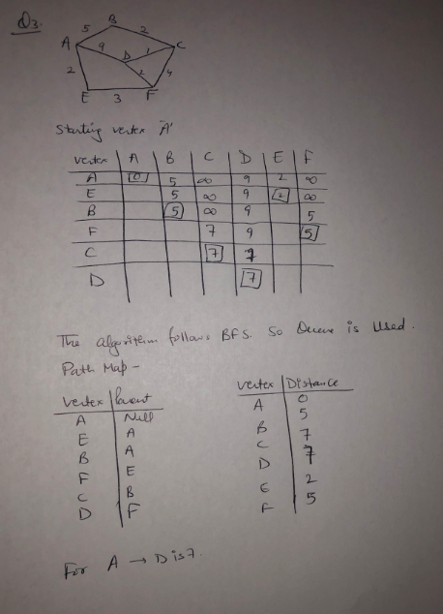

4. Consider Ford-Fulkerson Algorithm:

Explain step-by-step of how the algorithm works. Is there a recursive nature

to this algorithm? What is its termination point?

Begin

   initially mark all nodes as unvisited

   state of start as visited

   predecessor of start node is φ

   insert start into the queue qu

   while qu is not empty, do

      delete element from queue and set to vertex u

      for all vertices i, in the residual graph, do

         if u and i are connected, and i is unvisited, then

            add vertex i into the queue

            predecessor of i is u

            mark i as visited

      done

   done

   return true if state of sink vertex is visited

End

Answer – The algorithms detects maximum flow from starting vertex to sink vertex in graph. The source vertex has all outward edges(no inward), and sink has all inward edges(no outward).

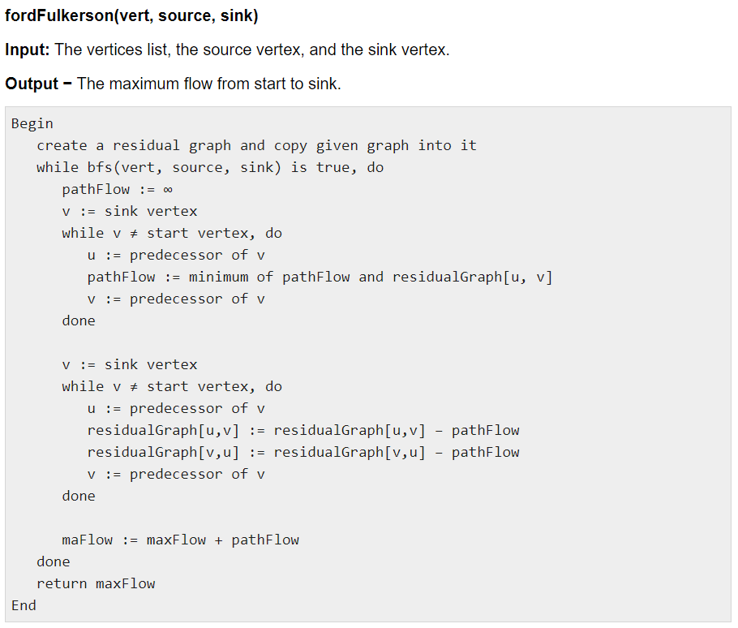

The algorithm first checks the flow is available or not from source to sink from the path flows between vertices. For that the algorithm is given below for BFS().

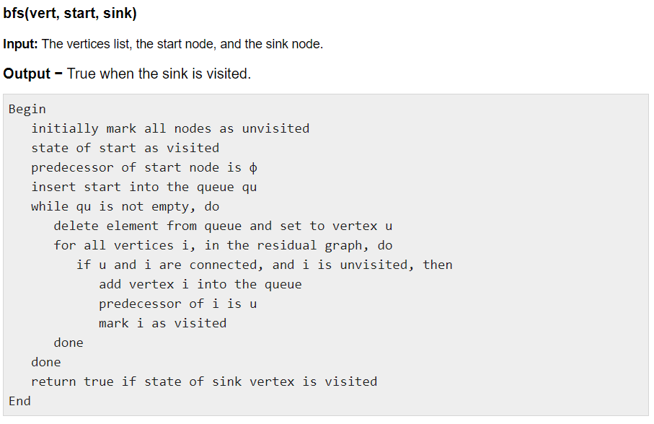

The BFS method uses the same set of inputs to see if there is a path from the start node to the sink vertex. It will go around all of the vertices. It will first display all unvisited nodes before moving on to the start vertex and declaring its predecessor null. Then add the visited nodes to the queue, one by one, in the order of first in first out, and then add the connected nodes to the queue. This will go on until the queue is no longer full. It will check whether the sink vertex has been visited or not after the Queue Traversal. It will return true if it has been visited; else, it will return false.

If the sink is accessed after receiving a response from BFS, the fordFulkerson algorithm will run. It will check for the shortest path flow from each node, then set the predecessor of vertices, and then go to the sink vertex. Then, in the same order as before, it will move from the sink vertex to the start vertex, subtracting the minimal path value from each edge until it reaches the start node.

The recursive approach determines the residual capacity for each edge by walking around the flow network starting at a specific node.

When the BFS algorithm returns false that the sink is not reachable from source that is the termination point which happens when any vertex’s all out going edge has residual capacity 0 and the flow is not possible from that vertex to any other vertex.

**5.** Same as Question 3

**6. Consider the following graph. Find Minimum Spanning Tree sub-graph of the graph using Kruscal’s algorithm. A) Explain data structures showing step-by-step algorithm to find the final solution presented in data structures. Note: Edge AB=3, AD=1, DC=1, BD=3, BC = 1; CE=5; CF=4, DE=6, FE=2**

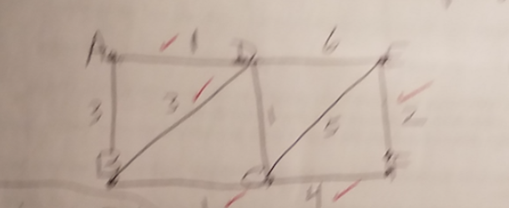

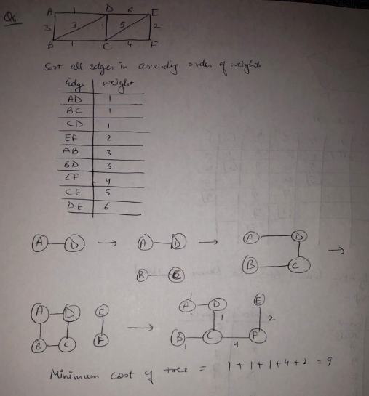

**7. Consider the following graph. Find Minimum Spanning Tree sub-graph of the graph using Prim’s algorithm. A) Explain data structures showing step-by-step algorithm to find the final solution presented in data structures. B) How to use Edge-table data structure to show the solution for minimum spanning tree**

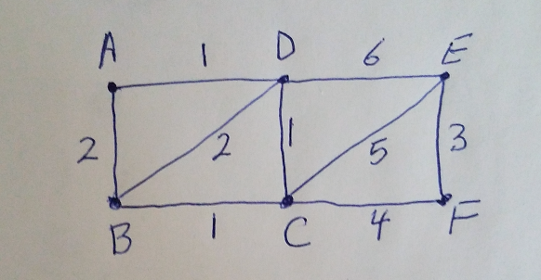

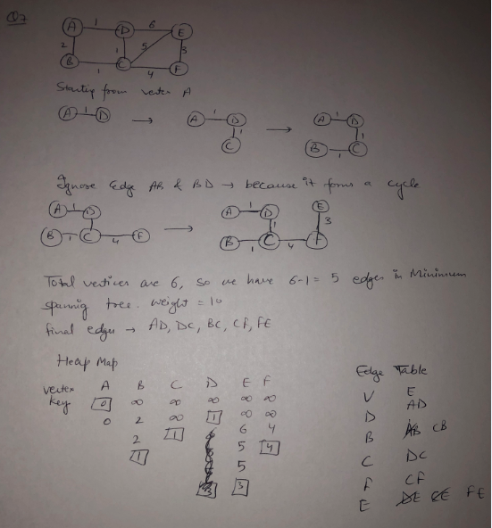

**C) How many Spanning Tree sub-graphs can you identify in the graph?**

If a graph is a complete graph with n vertices, then the total number of spanning trees is nCn-1.

Here there are 9 vertices so there will be 9C8 = 9 spanning trees.

**8. Solve Shortest path of this graph using Bellman-Ford algorithm, step-by-step with**

**Relaxation function.**

pasted-image.tiff

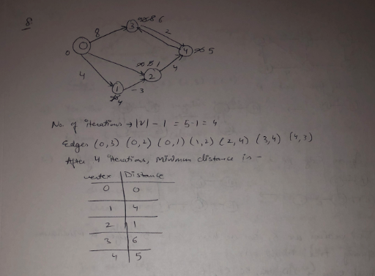

9. Consider the following bellman-ford graph

A) solve for shortest-path

B) A negative “cycle” makes the path shorter and shorter: Does this graph has

negative cycle? Yes/No explain

What does that mean? How to test for negative cycle?

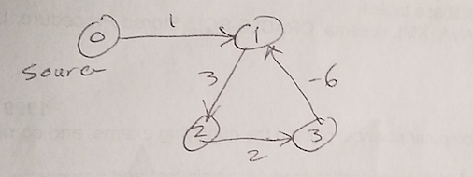

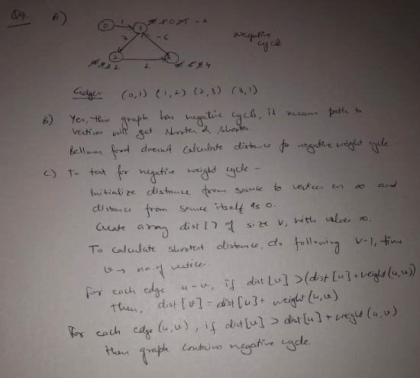

**10. Identify each of these algorithms, Explain in details**

**A)**

**1. Make a queue (Q) with all the vertices of G (V);**

**2. For each member of Q set the priority to INFINITY;**

**3. Only for the starting vertex (s) set the priority to 0;**

**4. The parent of (s) should be NULL;**

**5. While Q isn’t empty**

**6. Get the minimum from Q – let’s say (u); (priority queue);**

**7. For each adjacent vertex to (v) to (u)**

**8. If (v) is in Q and weight of (u, v) < priority of (v) then**

**9. The parent of (v) is set to be (u)**

**10. The priority of (v) is the weight of (u, v)**

Answer

Prim's algorithm for minimum spanning tree generation is provided. Prim maintains vertex in a priority Queue according to its algorithm. It sets all other priorities to infinity after setting the beginning vertex set priority to 0. The priority queue is then filled with all edges related to the vertex, and the lightest edge is picked. After that, all the edges that are not in the priority queue are appended to the queue at the next node connected by this edge. To build a spanning tree, the disjointed subsets of vertices must be joined. To make it a minimum spanning tree, they must be connected with the minimum weight edge.

Steps to create a minimum spanning tree algorithm with prim’s algorithm are as below:

* Create a set mstSet that keeps track of vertices already included in MST.
* Assign a key value to all vertices in the input graph.
* While mstset does not include all vertices.

1. Push a vertex which is not there in mstset and has a minimum key value.
2. Include u to mstset.

Update the key value of all adjacent vertices of u/ To update fix the key value. Iterate through all adjacent edges

B)

1. T is defined to be the empty set;

2. For each vertex v of G, make the empty set out of v;

3. Sort the edges of G in ascending (non-decreasing) order;

4. For each edge (u, v) from the sorted list of step 3.

If u and v belong to different sets

Add (u,v) to T;

Get together u and v in one single set;

5. Return T

Because it follows Kruskal's method, the steps to sort the given edges according to their weight and then create a spanning tree, the given algorithm is designated as Kruskal's algorithm.

As a result, this algorithm treats the graph as a forest and each node as a separate tree. A tree can only link to another tree if it has the lowest cost of all accessible edges and does not violate any rules.

MST properties.

1. Remove all loops and parallel edges and arrange all edges in their increasing order of weight.
2. Take the smaller weight edge, check if it forms a cycle with the spanning tree formed so far, if a cycle is formed then delete the edge, else include the edge in the queue.
3. Repeat step (ii) until all the vertex are connected and there are (v-1) edges.

**C)**

**1. Sort G into L;**

**2. Set the distance to the source to 0;**

**3. Set the distances to all other vertices to infinity;**

**4. For each vertex u in L**

**5. - Walk through all neighbors v of u;**

**6. - If dist(v) > dist(u) + w(u, v)**

**7. - Set dist(v) <- dist(u) + w(u, v);**

Answer - Dijkstra's algorithm is the name given to it. It's used to discover the shortest path between any selected vertex and all other vertices in a graph. As a result, the steps according to the algorithm are as follows.

i. Set all distances from start to infinity and from start to start to 0

ii. Make a list of unvisited vertices, then travel through its neighbors.

iii. Check if dist(v) > dist(u) + w(u,v), then dist(v) = dist(u) + w(u,v). Continue until all vertices are visited with least distance.